Robert Gutierrez

March 30, 2015

Senior Sem

**Gestapo of the 21st Century**

In 1933 there was group called the Gestapo in Nazi Germany, they were secret organization that conducted themselves as undercover police. The Gestapo mission was to write down anyone’s name that may potentially threat the country or anyone with probable cause to over throw the regime. Essentially showing the government’s control over the people. You may believe there is nothing wrong with this if you are a law-abiding citizen; however, it is something that should raise concern. In a state where there is constant surveillance there is opportunity to misinterpret information and also potential ways to infer wrongly of a person. Adding negative connotation based on friendships, hobbies, and literature can be extremely easy. It is not hard to derive a negative image based off miscellaneous facts. Even though physical police officers have been eliminated from today’s society, there have been new ways that have been created to mimic this occupation. Having privacy is something we should be given as a right. If we fail to obtain such right we must resort to other methods, such as anonymity, going incognito to protect our identity. The Internet is a hub of information and a primitive place where we can be targeted and often collected data of our actions in the Internet. Therefore software like TOR has been created to provide anonymity. This open software is community that enables a true incognito browsing.

Tor is a short acronym that stands for “The Onion Router”[1] it’s name like so because it encrypts your data in layers, simulating an onion with various layers. Tor is an open source project that was intended to be used by the U.S Naval Research Laboratory their main focus was to protect U.S intelligence communications online. When using Tor, you contribute to the network by becoming a node in the 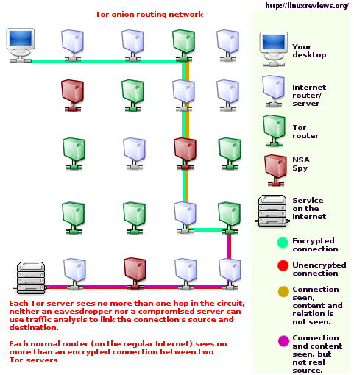community, which acts as a relay point for others in the community[2]. When you type your URL into the Tor browser it does not directly talk to the server but instead goes to another location, another Tor user, as a relay. Here it is decrypts to where it carries off information on where to relay again, and keeps leaping through various Tor users, until it finally leads to the server, which you originally tried to communicate with.

The speed of Tor is not great, because of the leaping within the network. However, that is a small price to pay when anonymity is crucial. Other detail to take into consideration is that, people can be detected if you are using Tor; however, they will not gain access to what you are doing because of the various layers that it must undergo. So the risk of your information being intercepted and read is less of a problem. Tor is the leading software for anonymity at the moment; however, it is a program often regarded, until we feel pressured or sense high risk.

In today’s world, in many countries we are open to use the Internet and roam “freely”, such as if we were to go outside, or at least it appears that way. However, the cold truth is that when we are roaming the Internet we are constantly getting tracked. Perhaps not always by deviant people with malice intentions, but none the less we leave a trail of crumbs in the Internet. This can derive a certain image of a person. It is not whether we participate in deviant or radical acts, but what an outsider, can interpret from our activity. For this sole reason it may behoove some of us to browse the Internet anonymously. Using Tor in some Middle Eastern countries is not much of a choice, but the only choice. There have been instances where the government has a high surveillance in the people that it blocks certain sites in order to keep the people in a dark, with limited information, information that can hinder progress. Even in the United States there have been leaks of information that show the government is keeping track of us. This may concern some, but privacy is something we should not take for granted. Internet is a place where there is no concrete law, partially because it is hard to put concrete rules, when each country conducts itself differently. However, as any citizen of any given country we deserve the right to walk anywhere we please, and that should not be any different when browsing the Internet.

Political movement is one of the few examples where TOR can be used. Other potential users are journalists[3] who are reporting from foreign country where sending sensitive information can be dangerous. Other users are Law enforcement, which can benefit from an anonymous tip. As well as conduction sting operation. But even higher ups in the corporate world can benefit from Tor; it may allow them to conduct truly private conversations, which may contain information that can be sensitive to the general public. Tor is a free service at the moment, and also service that should be continue to be funded, especially as anonymity gets more and more valuable.

1. "Tor." *Project: Overview*. Tor Project, n.d. Web. 27 Mar. 2015.
2. Dingledine, Roger, Nick Mathewson, and Paul Syverson. "Tor: The Second-Generation Onion Router." *Tor: The Second-Generation Onion Router*. N.p., n.d. Web. 29 Mar. 2015.
3. Misata, Kelly. "Getting to Know Tor, the Most Popular Anonymity Tool in the World." *PBS*. PBS, 20 Nov. 2013. Web. 27 Mar. 2015.